[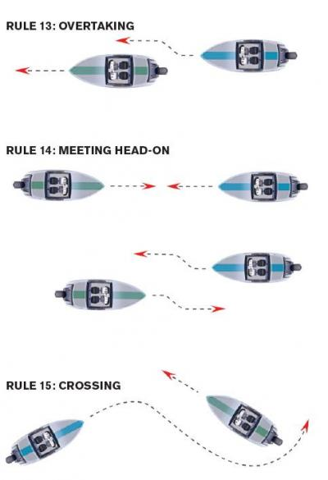](http://www.google.com/url?sa=i&rct=j&q=&esrc=s&source=images&cd=&cad=rja&uact=8&ved=0ahUKEwjw_M-P3dbQAhVN8WMKHaO5AqcQjRwIBw&url=http%3A%2F%2Fwww.bassmaster.com%2Ftips%2Fboat-safety-know-your-right-way&bvm=bv.139782543,d.cGc&psig=AFQjCNEnuZ1AZ9xxaWOVt2pY3Y3ZyQQGCA&ust=1480809925795653)Overtaking: Go to right

Being overtaken: keep line

Meeting head on: keep right

Crossing: give way to person ahead, and keep right.

[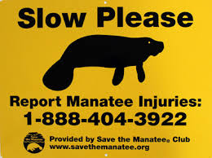](https://www.google.com/imgres?imgurl=http%3A%2F%2Fwww.savethemanatee.org%2Fed_sign_2015_400.jpg&imgrefurl=http%3A%2F%2Fwww.savethemanatee.org%2Fnews_pr_july_4_15.html&docid=QGvuD6RHYvZp1M&tbnid=RvVbH4bpozQ5NM%3A&vet=1&w=400&h=299&bih=643&biw=1366&ved=0ahUKEwjYmfrr3tbQAhUN7WMKHTdnAU4QMwhUKC0wLQ&iact=mrc&uact=8)

[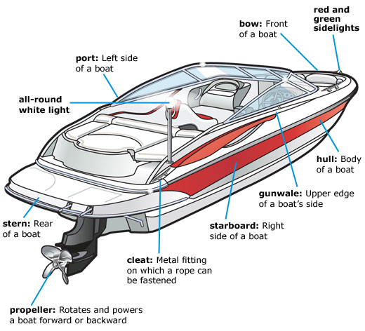](https://www.google.com/url?sa=i&rct=j&q=&esrc=s&source=images&cd=&cad=rja&uact=8&ved=0ahUKEwjlna_P39bQAhUB2mMKHWTkAYoQjRwIBw&url=https%3A%2F%2Fwww.boat-ed.com%2Fwashington%2FstudyGuide%2FParts-of-a-Boat-From-a-Side-View%2F10105001_700060585%2F&bvm=bv.139782543,d.cGc&psig=AFQjCNHKtfC-PkmpKrqRoakP2bgib7dYGA&ust=1480810617710921)[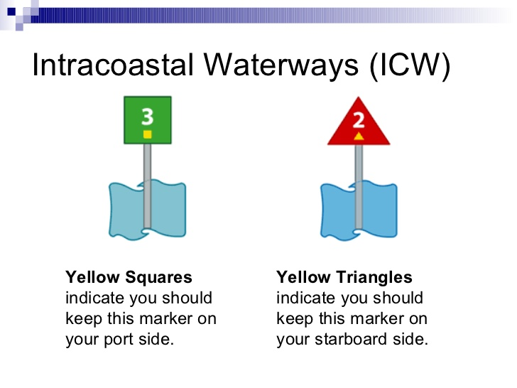](http://www.google.com/url?sa=i&rct=j&q=&esrc=s&source=images&cd=&cad=rja&uact=8&ved=0ahUKEwi439K039bQAhVS42MKHSzlBKUQjRwIBw&url=http%3A%2F%2Fwww.slideshare.net%2Fchrisatrtc%2F5-aton-chris-r-201107&bvm=bv.139782543,d.cGc&psig=AFQjCNHQ86pLJQkftZglgeeX2_fe1e96QQ&ust=1480810554210306)